S.A.V. BALAKRISHNA SCHOOL
Vadakkankulam, Tirunelveli District, Tamil Nadu 627116
CBSE/AFFILIATION/1930738

session: 2024-2025
A PROJECT REPORT ON

Organ Donation and Matching
Software

Submitted to submitted by:
mr. Bala benjamine J.SIJENNA
p.g.t.(comp. sc) V.RASHLIN KINGSTA
R.A.D.RAJA HARSHINI
Reg.no. :

  - CERTIFICATE

This is to certify that J.SIJENNA, V.RASHLIN KINGSTA ,
R.A.D.RAJA HARSHINI of class XII of SAV Balakrishna School as a team have done their project on Organ Donation and Matching Software under my supervision. They have taken interest and has shown at most sincerity in completion of this project.
I certify this Project up to my expectation & as per guidelines issued by CBSE, NEW DELHI.

Internal Examiner External Examiner

Principal

ACKNOWLEDGMENT

It is with pleasure that we acknowledge sincere gratitude to our teacher, Mr.B.BalaBenjamine who taught and undertook the responsibility of teaching the subject computer science. We have been greatly benefited from his classes.
We are especially indebted to our Principal Mr.B.BalaBenjamine who has always been a source of encouragement and support and without whose inspiration this project would not have been a successful we would like to place on record heartfelt thanks to him.
Finally, we would like to express our sincere appreciation for all the other students for their friendship & the fine times that we all shared together.

INTRODUCTION

This project is about managing the donor and recipient details within a hospital / transplant centre and allows us to find a donor for any particular recipient between hospitals / transplant centres. By automating the matching process and facilitating communication between the hospitals / transplant centres, this software can help increase the Organ Matching and Transplantation possibilities.

MODULES/PACKAGES USED
- mysql.connector - To connect with mysql with python.
- datetime – To get the current time and date.
- os-To create notification.
- platform-To create notification.
- random- To create random numbers for generating unique IDs.

USER DEFINED Functions USED
- create_hospital_table() – To create a table which contains the details of hospitals / transplant centres.
- VALID_password() – To check whether the inputted password is valid or not.
- Hospital_Register() – To register the hospital / transplant centre.
- unique_ID() – To generate unique for the hospitals / transplant centres.
- calculate_age() – To calculate the age of donor and recipient by using their date of birth.
- blood_type() – To check whether the inputted blood type is valid or not.
- organ_type() – To input the particular organ which the donor tends to donate or the recipient is in need.
- donor_menu() – To add or manipulate donor details.
- recipient_menu() – To add or manipulate recipient details.
- send_notification() – To create a notification.
- match_organ() – To match a donor for the particular recipient who is in need of an organ.
- is_compatible() – To check whether the donor can donate to the particular recipient or not.
- Hospital_menu() – To view hospital menu.
- confirmation() – To check whether the organ is available in the donor hospital / transplant centre.
- request() – To check whether the hospital / transplant centre has got any organ request.
- admin_menu() – To manage the hospitals details, requests.
- view_pending_requests() – To view the pending requests to the admin.
- view_pending_confirmations() – To view the pending confirmation requests to the admin.
- view_hospital_details() – To view hospitals / transplant centres details to the admin.
- admin_login() – To allow the admin to login the software.
- main_menu() – To view the homepage.
- donor_add() – To add new donor.
- recipient_add() – To add new recipient.
- Update_Donor() – To update the donor details.
- Update_Recipient() – To update the recipient details.
- search_donor() – To search any particular donor with their donor ID.
- search_recipient() – To search any particular recipient with their recipient ID.
- delete_donor() – To delete a donor.
- delete_recipient() – To delete a recipient.
- view_donor_list() – To view all the details of all the donors in that particular hospital / transplant centre.
- view_recipient_list() – To view all the details of all the recipients in that particular hospital / transplant centre.

SOURCE CODE
Program code

OUTPUT
Run the program and take the screenshots of each and every menu

REFERENCES
- WWW.GOOGLE.COM
- WWW.PYTHON.ORG

import os
import random
import platform
import mysql.connector as ms
from datetime import datetime

x=ms.connect(host="localhost",username="root",passwd="root",database="organ_donation_and_requesting_software")

cur=x.cursor()

def create_hospital_table():

hosp="create table if not exists HOSPITALS(Hospital_ID varchar(100) UNIQUE,H_password varchar(15) PRIMARY KEY,Hospital_Name varchar(50) Not Null,Hospital_Location varchar(100) Not Null,Contact_No decimal(10)) "

cur.execute(hosp)

request="create table if not exists REQUESTS(From_hosp_ID varchar(100),To_hosp_ID varchar(100),recipient_ID int,donor_ID int,checked_NOT_checked ENUM('checked','NOT checked') DEFAULT 'NOT checked')"

cur.execute(request)

confirm="create table if not exists CONFIRMATION(From_hosp_ID varchar(100),To_hosp_ID varchar(100),Confirm_availability ENUM('Available','Not Available','Reserved') NOT NULL,checked_NOT_checked ENUM('checked','NOT checked') NOT NULL)"

cur.execute(confirm)

x.commit()

def VALID_password():

password = input("Please enter the PASSWORD\U0001F512\U0001F511:")

while True:
if len(password) < 8:
print("Password must be at least 8 characters long.")
elif not any(char.isupper() for char in password):
print("Password must contain at least one uppercase letter.")
elif not any(char.islower() for char in password):
print("Password must contain at least one lowercase letter.")
elif not any(char.isdigit() for char in password):
print("Password must contain at least one number.")
elif not any(char in "!@#$%^~&*_" for char in password):
print("password must contain at least one special character(!@#$%^&*_)")
else:
return password
break

password = input("Please enter a VALID password: ")

def Hospital_Register():

cur=x.cursor()

cur.execute("select * from Hospitals")

Hospital_details=cur.fetchall()

Hospital_Name=input("enter name\U0001F9AA:").lower()

def unique_ID():

while True:
unique_numbers = random.sample(range(1, 100), 3)

uid="".join(Hospital_Name.split())+"_"

for i in unique_numbers:
uid=uid+str(i)

for ids in Hospital_details:

if ids[0] != uid:

return uid

Hospital_ID=unique_ID()

print("YOUR ID : ",Hospital_ID)

H_Password=VALID_password()

Hospital_Location=input("Enter the Hospital Location \U0001F4CD")

Contact_No=int(input("Enter the Contact number \U0001F4DE"))

insert="""insert into HOSPITALS(Hospital_ID,H_Password,Hospital_Name,Hospital_Location,Contact_No) values(%s,%s,%s,%s,%s)"""
data=(Hospital_ID,H_Password,Hospital_Name,Hospital_Location,Contact_No)

cur.execute(insert,data)

x.commit()

donor_table_name=f"{Hospital_ID}_donors"

donor=f"""create table if not exists {donor_table_name}(donor_NOTTO_ID int,donor_name varchar(30),donor_gender varchar(1),donor_DOB date,donor_age int,donor_phno decimal(10),donor_Address varchar(100),donor_organ_type varchar(20),donor_organ_size varchar(100),donor_blood_type varchar(10),Availability_Status ENUM('Available','Reserved','NOT Available') NOT NULL )"""

cur.execute(donor)

recipient_table_name=f"{Hospital_ID}_recipients"

recipient=f"""create table if not exists {recipient_table_name}(recipient_NOTTO_ID int,recipient_name varchar(30),recipient_gender varchar(1),recipient_DOB date,recipient_age int,recipient_phno decimal(10),recipient_Address varchar(100),recipient_organ_type varchar(20),recipient_organ_size varchar(100),recipient_blood_type varchar(10))"""

cur.execute(recipient)
x.commit()
print("\t\t\tRegistered succcessfully!!!")
main_menu()

def calculate_age(dob):
today = datetime.today()
dob = datetime.strptime(dob, '%Y-%m-%d')
age = today.year - dob.year - ((today.month, today.day) < (dob.month, dob.day))
return age

def blood_type():
bloodtype=input("Enter the blood type \U0001FA78").strip()
valid_blood_types=["A+","A-","B+","B-","AB+","AB-","O+","O-"]
if bloodtype in valid_blood_types:
return bloodtype
else:
print("\nINVALID BLOOD TYPE !!!\n please entry valid blood type\n")
blood_type()

def organ_type():
print("\t\t\t>>>ORGAN TISSUE TYPES<<<")

print("\t\t\t------------------------------\n")

print("\t\t1.KIDNEY\t\t2.LIVER\t\t3.HEART \U00002764\U0000FE0F\n")

print("\t\t4.BLOOD \U0001FA78\t5.PANCREAS\t6.EYE TISSUES \U0001F441\n")

print("\t\t\t\t7.SKIN ")
print(107*"=",'\n')
choice=int(input("Enter your Choice:"))
if choice==1:
return "KIDNEY"

elif choice==2:
return "LIVER"

elif choice==3:
print("1. HEART VALVE")
print("2. HEART")
choice=int(input("Enter your choice"))
if choice==1:
return "HEART VALVE"

elif choice==2:
return "HEART"

else:
print("\nINVALID ORGAN TYPE !!!\n please entry valid organ type\n")
organ_type()
elif choice==4:
return "BLOOD"

elif choice==5:
return "PANCREAS"

elif choice==6:
print("\t\t\t>>>EYE TISSUE TYPES<<<")

print("\t\t\t-------------------------\n")
print("\t\t1. CORNEA\t\t\t2. SCLERA\n")
choice=int(input("Enter your choice:"))
if choice==1:
return "CORNEA"

elif choice==2:
return "SCLERA"

else:
print("\nINVALID ORGAN TYPE !!!\n please entry valid organ type\n")
organ_type()
elif choice==7:
return "SKIN"

else:
print("\nINVALID CHOICE!!!\nplease enter valid choice\n")
organ_type()

def donor_add():

print("\t\t\t>>>>PERSONAL DETAILS<<<<")

print("\t\t\t------------------------------\n")
donor_NOTTO_ID=input("Enter DONOR's NOTTO \U0001F194")
donor_name=input("Enter donor's full name \U0001F58B:")
donor_gender=input("Enter donor's Gender [M/F]\u2642/\u2640")
if __name__ == "__main__":
donor_DOB= input("Enter DONOR's date of birth (YYYY-MM-DD): ")
try:
donor_age = calculate_age(donor_DOB)
except ValueError:
print("INVALID date format. Please use YYYY-MM-DD.")

donor_phno=int(input("Enter the donor's phone number\U0001F4DE:"))
donor_Address=input("Enter the Address of the Donor \U0001F3E0:")
print(106*"=",'\n')

print("\t\t\t>>>>MEDICAL INfORMATION<<<<")

print("\t\t\t----------------------------------\n")
donor_organ_type=organ_type()
donor_organ_size=input("Enter the size of the Organ [(Length)cm x (Width)cm x (Thickness)cm]/ Blood units").lower().strip()

donor_blood_type=blood_type()
Valid_Availability_Status=['available','reserved','not available']

Availability_Status=input("Enter the Availability Status ['Available','Reserved','NOT Available'] : ")

while Availability_Status.lower() not in Valid_Availability_Status:
print("INVALID Availability Status!!!")

Availability_Status=input("Enter the Availability Status ['Available','Reserved','NOT Available'] : ")

cur=x.cursor()
donor_table_name=f"{ID[0]}_donors"

insert=f"""insert into {donor_table_name}(donor_NOTTO_ID,donor_name,donor_gender,donor_DOB,donor_age,donor_phno,donor_Address,donor_organ_type,donor_organ_size,donor_blood_type,Availability_Status) values(%s,%s,%s,%s,%s,%s,%s,%s,%s,%s,%s)"""

data=(donor_NOTTO_ID,donor_name,donor_gender,donor_DOB,donor_age,donor_phno,donor_Address,donor_organ_type,donor_organ_size,donor_blood_type,Availability_Status)

cur.execute(insert,data)
x.commit()
ans=input("Enter y to add more DONORS: ").lower()
print(106*"=",'\n')
if ans=="y":
donor_add()
else:
donor_menu()

def recipient_add():

print("\t\t\t>>>>PERSONAL DETAILS<<<<")

print("\t\t\t------------------------------\n")
recipient_NOTTO_ID=input("Enter RECIPIENT's NOTTO \U0001F194")
recipient_name=input("Enter recipient's full name \U0001F58B:")
recipient_gender=input("Enter recipient's gender \u2642/\u2640:")
if __name__ == "__main__":

recipient_DOB= input("Enter recipient's date of birth (YYYY-MM-DD): ")
try:
recipient_age = calculate_age(recipient_DOB)
except ValueError:
print("INVALID date format. Please use YYYY-MM-DD.")

recipient_phno=int(input("Enter the recipient's phone \U0001F4DE"))
recipient_address=input("Enter the recipient's address \U0001F3E0")
print(106*"=",'\n')

print("\t\t\t>>>>MEDICAL INfORMATION<<<<")

print("\t\t\t----------------------------------\n")
recipient_organ_type=organ_type()

recipient_organ_size=input("Enter the size of the Organ[(Length)cm x (Width)cm x (Thickness)cm]/ Blood units").strip()

recipient_blood_type=blood_type()
cur=x.cursor()
recipient_table_name=f"{ID[0]}_recipients"

insert=f"""insert into {recipient_table_name}(recipient_NOTTO_ID,recipient_name,recipient_gender,recipient_DOB,recipient_age,recipient_phno,recipient_Address,recipient_organ_type,recipient_organ_size,recipient_blood_type) values(%s,%s,%s,%s,%s,%s,%s,%s,%s,%s)"""

data=(recipient_NOTTO_ID,recipient_name,recipient_gender,recipient_DOB,recipient_age,recipient_phno,recipient_Address,recipient_organ_type,recipient_organ_size,recipient_blood_type)

cur.execute(insert,data)
x.commit()
ans=input("Enter y to add more RECIPIENT: ").lower()
print(106*"=",'\n')
if ans=="y":
recipient_add()
else:
recipient_menu()

def Update_Donor():

print("\t\t\t>>>UPDATE DONOR DETAILS<<<")

print("\t\t\t-----------------------------------\n")
donor_table_name = f"{ID[0]}_donors"

donor_NOTTO_ID = int(input("Enter the DONOR's NOTTO \U0001F194:"))

print("\t1.Donor's Phone number \U0001F4DE\t\t2.Donor's Address \U0001F3E0")

print("\t3.Donor's Organ type \U0001F9E0\t\t4.Donor's Organ size \U0001F52C")

print("\t5.Donor's Blood type \U0001FA78\t\t6.Availability Status")
choice = int(input("Enter the choice you want to UPDATE:"))

if choice == 1:
donor_phno = int(input("Enter the NEW phone number \U0001F4DE"))
cur = x.cursor()

update = f"""UPDATE {donor_table_name} SET donor_phno = %s WHERE donor_NOTTO_ID = %s"""
cur.execute(update, (donor_phno, donor_NOTTO_ID))
x.commit()

elif choice == 2:
donor_Address = input("Enter the NEW address: \U0001F3E0 ")
cur = x.cursor()

update = f"""UPDATE {donor_table_name} SET donor_Address = %s WHERE donor_NOTTO_ID = %s"""

cur.execute(update, (donor_Address, donor_NOTTO_ID))
x.commit()

elif choice == 3:
donor_organ_type = organ_type()
cur = x.cursor()

update = f"""UPDATE {donor_table_name} SET donor_organ_type = %s WHERE donor_NOTTO_ID = %s"""

cur.execute(update, (donor_organ_type, donor_NOTTO_ID))
x.commit()

elif choice == 4:
donor_organ_size = input("Enter the Organ Size: ")
cur = x.cursor()

update = f"""UPDATE {donor_table_name} SET donor_organ_size = %s WHERE donor_NOTTO_ID = %s"""

cur.execute(update, (donor_organ_size, donor_NOTTO_ID))
x.commit()

elif choice == 5:
donor_blood_type = blood_type()
cur = x.cursor()

update = f"""UPDATE {donor_table_name} SET donor_blood_type = %s WHERE donor_NOTTO_ID = %s"""

cur.execute(update, (donor_blood_type, donor_NOTTO_ID))
x.commit()

elif choice == 6:
Valid_Availability_Status = ['available', 'reserved', 'not available']

Availability_Status = input("Enter the Availability Status ['Available','Reserved','NOT Available'] : ")

while Availability_Status.lower() not in Valid_Availability_Status:
print("INVALID Availability Status!!!")

Availability_Status = input("Enter the Availability Status ['Available','Reserved','NOT Available'] : ")

cur = x.cursor()

update = f"""UPDATE {donor_table_name} SET Availability_Status = %s WHERE donor_NOTTO_ID = %s"""

cur.execute(update, (Availability_Status, donor_NOTTO_ID))
x.commit()

ans = input("Enter y to update more donor details : ").lower()
print(106*"=",'\n')
if ans == "y":
Update_Donor()
else:
donor_menu()

def Update_Recipient():

print("\t\t\t>>>UPDATE RECIPIENT DETAILS<<<")

print("\t\t\t-----------------------------------\n")
recipient_table_name = f"{ID[0]}_recipients"

recipient_NOTTO_ID = int(input("Enter recipient's NOTTO ID\U0001F194 : "))

print("\t1.Recipient's Phone number\U0001F4DE:\t 2.Recipient's Address \U0001F3E0:")

print("\t3.Recipient's Organ type\U0001F9E0 : \t4.Recipient's Organ size\U0001F52C :")

print("\t5.Recipient's Blood type \U0001FA78 : \t6.EXIT\n")

choice = int(input("Enter the choice you want to UPDATE: "))

if choice == 1:

recipient_phno = int(input("Enter the NEW phone number\U0001F4DE : "))
cur = x.cursor()

update = f"""UPDATE {recipient_table_name} SET recipient_phno = %s WHERE recipient_NOTTO_ID = %s"""

cur.execute(update, (recipient_phno, recipient_NOTTO_ID))
x.commit()

elif choice == 2:
recipient_Address = input("Enter the NEW address\U0001F3E0 : ")
cur = x.cursor()

update = f"""UPDATE {recipient_table_name} SET recipient_Address = %s WHERE recipient_NOTTO_ID = %s"""

cur.execute(update, (recipient_Address, recipient_NOTTO_ID))
x.commit()

elif choice == 3:
recipient_organ_type = organ_type()
cur = x.cursor()

update = f"""UPDATE {recipient_table_name} SET recipient_organ_type = %s WHERE recipient_NOTTO_ID = %s"""

cur.execute(update, (recipient_organ_type, recipient_NOTTO_ID))
x.commit()

elif choice == 4:
recipient_organ_size = input("Enter the Organ Size: ").lower()
cur = x.cursor()

update = f"""UPDATE {recipient_table_name} SET recipient_organ_size = %s WHERE recipient_NOTTO_ID = %s"""

cur.execute(update, (recipient_organ_size, recipient_NOTTO_ID))
x.commit()

elif choice == 5:
recipient_blood_type = blood_type()
cur = x.cursor()

update = f"""UPDATE {recipient_table_name} SET recipient_blood_type = %s WHERE recipient_NOTTO_ID = %s"""

cur.execute(update, (recipient_blood_type, recipient_NOTTO_ID))
x.commit()

ans = input("Enter 'y' to update more recipient details, or any other key to exit: ").lower()

if ans=="y":
Update_Recipient()
else:
recipient_menu()

def search_donor():

while True:
donor_ID = int(input("\nEnter donor's NOTTO ID: "))
donor_table_name = f"{ID[0]}_donors"
cur = x.cursor()
check_donor = f"SELECT COUNT(*) FROM {donor_table_name} WHERE donor_NOTTO_ID = %s"

cur.execute(check_donor,(donor_ID,))
count = cur.fetchone()[0]
if count == 0:

print(f"Donor with NOTTO ID {donor_ID} not found. Please enter a valid NOTTO ID.")

continue

donor_detail = f"SELECT * FROM {donor_table_name} WHERE donor_NOTTO_ID = %s"

cur.execute(donor_detail, (donor_ID,))
donor_list = cur.fetchone()

if donor_list:
H_donor = [i[0] for i in cur.description]
for i, j in zip(H_donor, donor_list):
print(i, " : ", j)

continue_search = input("\nDo you want to search for another donor? (yes/no): ").lower()

if continue_search =="yes":
search_donor()
else:
donor_menu()

def search_recipient():

while True:
recipient_ID = int(input("\nEnter recipient's NOTTO ID: "))
recipient_table_name = f"{ID[0]}_recipients"
cur = x.cursor()
check_recipient = f"SELECT COUNT(*) FROM {recipient_table_name} WHERE recipient_NOTTO_ID = %s"

cur.execute(check_recipient, (recipient_ID,))
count = cur.fetchone()[0]

if count == 0:

print(f"Recipient with NOTTO ID {recipient_ID} not found. Please enter a valid NOTTO ID.")

continue

recipient_detail = f"SELECT * FROM {recipient_table_name} WHERE recipient_NOTTO_ID = %s"

cur.execute(recipient_detail, (recipient_ID,))
recipient_list = cur.fetchone()
if recipient_list:
H_recipient = [i[0] for i in cur.description]
for i, j in zip(H_recipient, recipient_list):
print(i, " : ", j)

continue_search = input("\nDo you want to search for another recipient? (yes/no): ").lower()

if continue_search =="yes":
search_recipient()
else:
recipient_menu()

def delete_donor():

while True:
donor_ID=int(input("Enter Donor's NOTTO ID"))
donor_table_name=f"{ID[0]}_donors"
cur=x.cursor()

check_donor = f"SELECT COUNT(*) FROM {donor_table_name} WHERE donor_NOTTO_ID = %s"

cur.execute(check_donor,(donor_ID,))
count = cur.fetchone()[0]

if count == 0:

print(f"Donor with NOTTO ID {donor_ID} not found. Please enter a valid NOTTO ID.")

continue

donor_del = f"DELETE FROM {donor_table_name} WHERE donor_NOTTO_ID = %s"

cur.execute(donor_del, (donor_ID,))
x.commit()
print("Donor deleted successfully !!!")

continue_del= input("\nDo you want to delete another donor? (yes/no): ").lower()

if continue_search =="yes":
delete_donor()
else:
donor_menu()

def delete_recipient():

while True:
recipient_ID=int(input("Enter Recipient's NOTTO ID"))
recipient_table_name=f"{ID[0]}_recipients"
cur=x.cursor()

check_recipient = f"SELECT COUNT(*) FROM {recipient_table_name} WHERE recipient_NOTTO_ID = %s"

cur.execute(check_recipient,(recipient_ID,))
count = cur.fetchone()[0]
if count == 0:
print(f"Recipient with NOTTO ID {recipient_ID} not found. Please enter a valid NOTTO ID.")

continue

recipient_del = f"DELETE FROM {recipient_table_name} WHERE recipient_NOTTO_ID = %s"

cur.execute(recipient_del, (recipient_ID,))
x.commit()
print("Recipient deleted successfully !!!")

continue_del= input("\nDo you want to delete another recipient? (yes/no): ").lower()

if continue_search =="yes":
delete_recipient()
else:
recipient_menu()

def view_donor_list():

donor_table_name = f"{ID[0]}_donors"
cur = x.cursor()
donor_list = f"select * from {donor_table_name}"
cur.execute(donor_list)
data = cur.fetchall()
H_donor = [i[0] for i in cur.description]
for i in range(len(data)):
print(f"DONOR {i+1}:")
print("-"*192)
donor_info = dict(zip(H_donor, data[i]))
for key, value in donor_info.items():
print(f"{key} : {value}")
print("\n" + "-"*192)
x.commit()
print("="*106)
donor_menu()

def view_recipient_list():

recipient_table_name = f"{ID[0]}_recipients"
cur = x.cursor()
recipient_list = f"select * from {recipient_table_name}"
cur.execute(recipient_list)
data = cur.fetchall()
H_recipient = [i[0] for i in cur.description]
for i in range(len(data)):
print(f"RECIPIENT{i+1}:")
print("-"*192)
recipient_info = dict(zip(H_recipient, data[i]))
for key, value in recipient_info.items():
print(f"{key} : {value}")
print("\n" + "-"*192)
x.commit()
print("="*106)
recipient_menu()

def donor_menu():

print(192*"-")

print("\n\t\t\t\tDONOR MENU\n")

print("\t\t1. Add Donor \U00002795 \U0001F464\t\t2. Update Donor \U00002795\n")

print("\t\t3. Search Donor \U0001F50E\t\t4. Delete Donor \u274C\n")

print("\t\t5. View Donor list \U0001F4CB\t6. EXIT \U0001F6B6\n")

choice=int(input("Enter your choice:"))
print(192*"-","\n")
if choice==1:
donor_add()
elif choice==2:
Update_Donor()
elif choice==3:
search_donor()
elif choice==4:
delete_donor()
elif choice==5:
view_donor_list()
elif choice==6:
Hospital_menu()
else:
print("INVALID Choice!!!\nPlease Enter VALID choice\n")
donor_menu()

def recipient_menu():

print(192*"-")

print("\n\t\t\t\tRECIPIENT MENU\n")

print("\t\t1. Add Recipient \U00002795 \U0001F464\t\t2. Update Recipient \U00002795\n")

print("\t\t3. Search Recipient \U0001F50E\t\t4. Delete \u274C\n")

print("\t\t5. View Recipient list \U0001F4CB\t\t6. EXIT \U0001F6B6\n")

choice=int(input("Enter your choice:"))
print(192*"-","\n")
if choice==1:
recipient_add()
elif choice==2:
Update_Recipient()
elif choice==3:
search_recipient()
elif choice==4:
delete_recipient()
elif choice==5:
view_recipient_list()
elif choice==6:
Hospital_menu()
else:
print("INVALID Choice!!!\nPlease Enter VALID choice\n")
recipient_menu()

def send_notification(title, message):

current_platform = platform.system()

if current_platform == "Windows":
os.system(f'msg * "{message}"')
elif current_platform == "Darwin": # macOS

os.system(f'osascript -e \'display notification "{message}" with title "{title}"\'')

elif current_platform == "Linux":
os.system(f'notify-send "{title}" "{message}"')
else:
print("Unsupported OS")

def match_organ():

cur = x.cursor()
print(106*'=')

print("\t\t\t\t MATCHING SYSTEM ")

print(106*'=')
recipient_ID = int(input("Enter recipient's NOTTO ID to MATCH: "))
recipient_table_name = f"{ID[0]}_recipients"

recipient_details = f"""SELECT recipient_organ_type, recipient_organ_size
FROM {recipient_table_name}
WHERE recipient_NOTTO_ID = %s"""

cur.execute(recipient_details, (recipient_ID,))
data = tuple(cur.fetchall())

if not data:
print("\t\t\t\tRecipient not found.\u2757")
print("\t\t\tPlease enter VALID Recipient ID!!!!")
match_organ()
return

organ_type, organ_size = data[0]

print("\t\t\tProccessing Recipient's Details.......\n")

time.sleep(3)

print("\t\t\tFinding Match for the Recipient......\n")

time.sleep(3)
cur.execute("SHOW TABLES")
tables = cur.fetchall()
donor_tables = [table[0] for table in tables if table[0].endswith('_donors')]

matched_donors = []

for table in donor_tables:

query = f"""SELECT EXISTS(SELECT * FROM {table}
WHERE donor_organ_type = %s
AND donor_organ_size = %s
AND Availability_Status = 'Available')"""

cur.execute(query, (organ_type, organ_size))
organ_match = cur.fetchone()

if organ_match[0] == 1:

query_donor = f"""SELECT donor_NOTTO_ID, donor_name, donor_gender, donor_DOB, donor_age, donor_phno, donor_Address, donor_organ_type, donor_organ_size, donor_blood_type FROM {table} WHERE donor_organ_type = %s AND donor_organ_size = %s"""

cur.execute(query_donor, (organ_type, organ_size))
blood_donor = cur.fetchall()

for donor in blood_donor:
donor_blood = donor[9]
donor_ID = donor[0]

query_recipient = f"""SELECT recipient_blood_type
FROM {recipient_table_name}
WHERE recipient_NOTTO_ID = %s"""

cur.execute(query_recipient, (recipient_ID,))
blood_recipient = cur.fetchall()

for recipient in blood_recipient:
recipient_blood = recipient[0]

if is_compatible(donor_blood, recipient_blood):
matched_donors.append(donor)

print("\t\t\t\tMATCH FOUND!!!\n")

time.sleep(1)
print(f"\t\t\t{donor_ID} can donate organ to {recipient_ID}.")
else:
print(f"\t\tNo donor match found for {recipient_ID}.")

if matched_donors:

print("\nMATCHED DONORS :\n")

for donor in matched_donors:

print(
f"Donor NOTTO ID: {donor[0]}\n"
f"Donor name: {donor[1]}\n"
f"Donor gender: {donor[2]}\n"
f"Donor DOB: {donor[3]}\n"
f"Donor age: {donor[4]}\n"
f"Donor phno: {donor[5]}\n"
f"Donor Address: {donor[6]}\n"
f"Donor organ type: {donor[7]}\n"
f"Donor blood type: {donor[9]}\n"
f"Availability Status: Available\n\n"
)

donor_matched_ID = int(input("Enter the DONOR's ID to SEND CONFIRMATION REQUEST: "))

for table_name in donor_tables:

query = f"SELECT donor_name FROM {table_name} WHERE donor_NOTTO_ID = %s"

cur.execute(query, (donor_matched_ID,))
result = cur.fetchone()

if result:

hospital_ID= table_name.replace("_donors", "")

send_request = """INSERT INTO requests(From_hosp_ID, To_hosp_ID, recipient_ID, donor_ID, checked_NOT_checked)
VALUES(%s, %s, %s, %s, %s)"""

values = (ID[0], hospital_ID, recipient_ID, donor_matched_ID, 'NOT checked')

cur.execute(send_request, values)
x.commit()

print("\n\t\tConfirmation request sent successfully!!!\n")

ask=input("Do you want to match any other recipient (Yes/No): ").strip()
if ask=="yes":
match_organ()
else:
Hospital_menu()
return

else:
print("NO matched donors found.")
ask=input("Do you want to match any other recipient (Yes/No): ").strip()
if ask=="yes":
match_organ()
else:
Hospital_menu()
print(106*'=')

def is_compatible(donor: str, recipient: str) -> bool:

blood_compatibility = {
'O-': ['O-', 'A-', 'B-', 'AB-', 'O+', 'A+', 'B+', 'AB+'],
'O+': ['O+', 'A+', 'B+', 'AB+'],
'A-': ['A-', 'AB-', 'A+', 'AB+'],
'A+': ['A+', 'AB+'],
'B-': ['B-', 'AB-', 'B+', 'AB+'],
'B+': ['B+', 'AB+'],
'AB-': ['AB-', 'AB+'],
'AB+': ['AB+']
}

donor = donor.upper()
recipient = recipient.upper()

if donor in blood_compatibility:
return recipient in blood_compatibility[donor]
else:
raise ValueError("Invalid blood type input.")

def Hospital_menu():

print(192*"-")

print("\n\t\t\t\tMAIN MENU\n")

print("\t\t1. Donors\t\t\t\t2. Recipients\n")
print("\t\t3. Match Organ\t\t\t4. EXIT\n")
choice=int(input("Enter your choice:"))
print(192*"-","\n")
if choice==1:
donor_menu()
elif choice==2:
recipient_menu()
elif choice==3:
match_organ()
elif choice==4:
main_menu()
else:
print("Enter a VALID choice!!!!\n")
Hospital_menu()

def confirmation():

cur = x.cursor()

query = "SELECT * FROM confirmation WHERE checked_NOT_checked='NOT checked'"

cur.execute(query)
confirm_requests = cur.fetchall()

has_pending_requests = False

for confirm_request in confirm_requests:
if confirm_request[1] == ID[0]:
has_pending_requests = True

send_notification("Hello!", "Got a Confirmation Notification!!!")
y_n = input("Do you want to open the confirmation request NOW!!! (Yes/No) : ").lower()

if y_n == "yes":

hospital_name = confirm_request[0].split('_')[0]

query = "SELECT Hospital_Name, Hospital_Location, Contact_No FROM hospitals WHERE Hospital_ID=%s"

cur.execute(query,(confirm_request[0],))
hosp_details=cur.fetchall()
print("Hospital Name : ",hosp_details[0][0])
print("Hospital Location : ",hosp_details[0][1])
print("Contact No : ",hosp_details[0][2])
print("Recipient ID : ",confirm_request[4])
print("Matched Donor ID : ",confirm_request[5])

upt_query = "UPDATE confirmation SET checked_NOT_checked='checked' WHERE recipient_ID=%s AND donor_ID=%s"

upt_info = (confirm_request[4], confirm_request[5])
cur.execute(upt_query, upt_info)
x.commit()

return has_pending_requests

def request():

cur = x.cursor()

query = "SELECT * FROM requests WHERE checked_NOT_checked = 'NOT checked'"

cur.execute(query)
requests = cur.fetchall()

if len(requests) > 0:
print("Requests fetched successfully")

for request in requests:
if request[1] == ID[0]:
hospital_name = request[0].split("_")
Rhospital_name = request[0] + "_recipients"
Dhospital_name = ID[0] + "_donors"
message = "Got an organ request from: " + hospital_name[0]
send_notification("Hello!", message)
print(f"From_hospital: {Rhospital_name}\n")
print("\tRecipient Details:\n")

query = f"SELECT * FROM {Rhospital_name} WHERE recipient_NOTTO_ID = %s"

cur.execute(query, (request[2],))
recipient_detail = cur.fetchone()

print("\n\t\t# Recipient Details📄:\n")

print("\n\t\t\t Recipient NOTTO ID :",recipient_detail[0])
print("\t\t\t Recipient Name :",recipient_detail[1])
print("\t\t\t Recipient Gender :",recipient_detail[2])
print("\t\t\t Recipient DOB :",recipient_detail[3])
print("\t\t\t Recipient Age :",recipient_detail[4])
print("\t\t\t Recipient Phno:",recipient_detail[5])
print("\t\t\t Recipient Address :",recipient_detail[6])
print("\t\t\t Recipient Organ type :",recipient_detail[7])
print("\t\t\t Recipient Organ size/blood units :",recipient_detail[8])
print("\t\t\t Recipient Blood type :",recipient_detail[9])

print("\t\nMatched Donor Details:\n")

query = f"SELECT * FROM {Dhospital_name} WHERE donor_NOTTO_ID = %s"

cur.execute(query, (request[3],))
donor_detail = cur.fetchone()

print("\n\t\t# Donor Details📄:\n")

print("\n\t\t\t Donor NOTTO ID :",donor_detail[0])
print("\t\t\t Donor Name :",donor_detail[1])
print("\t\t\t Donor Gender :",donor_detail[2])
print("\t\t\t Donor DOB :",donor_detail[3])
print("\t\t\t Donor Age :",donor_detail[4])
print("\t\t\t Donor Phno:",donor_detail[5])
print("\t\t\t Donor Address :",donor_detail[6])
print("\t\t\t Donor Organ type :",donor_detail[7])
print("\t\t\t Donor Organ size/blood units :",donor_detail[8])
print("\t\t\t Donor Blood type :",donor_detail[9])

print("\t\t\t Donor Availability Status ['Available'/'Not Available'/'Reserved']:",donor_detail[10])

print("\n\t\t\tWhether the DONOR is available???")
print("Enter ['Available'/'Not Available'/'Reserved']")
Confirm_availability = input()

insert_query = "INSERT INTO confirmation (From_hosp_ID, To_hosp_ID, Confirm_availability, checked_NOT_checked, recipient_ID, donor_ID) VALUES (%s, %s, %s, %s, %s, %s)"

info = (ID[0], request[0], Confirm_availability, 'NOT checked', request[2], request[3])

cur.execute(insert_query, info)

upt_query = """UPDATE requests SET checked_NOT_checked = 'checked' WHERE recipient_ID = %s AND donor_ID = %s"""

upt_info = (request[2], request[3])
cur.execute(upt_query, upt_info)

x.commit()
return True

else:
return True

def admin_menu():

print("\t\t\tAdmin Menu\U0001F6E1\U0001F4CB:\n")

print("\t1. View Pending Requests\t\t2. View Pending Confirmations")
print("\t3. View Hospital Details\t\t4. Exit\U0001F6B6\n")
choice = int(input("Enter your choice\U0001F4DD: "))

if choice == 1:
view_pending_requests()
elif choice == 2:
view_pending_confirmations()
elif choice == 3:
view_hospital_details()
elif choice == 4:
print("Exiting Admin Menu...\U0001F6AA\U0001F6B6")
main_menu()
else:
print("Invalid choice, please try again.")
admin_menu()

def view_pending_requests():
cur = x.cursor()
query = "SELECT * FROM requests WHERE checked_NOT_checked = 'NOT checked'"
cur.execute(query)
requests = cur.fetchall()

if not requests:
print("No pending requests found.")
else:
print("Pending Requests:")
for request in requests:
print(f"From Hospital: {request[0]}, To Hospital: {request[1]}")
print(f"Recipient ID: {request[2]}, Donor ID: {request[3]}")

admin_menu()

def view_pending_confirmations():

cur = x.cursor()

query = "SELECT * FROM confirmation WHERE checked_NOT_checked = 'NOT checked'"

cur.execute(query)
confirmations = cur.fetchall()

if not confirmations:
print("No pending confirmations found.")
else:
print("Pending Confirmations:")
for confirmation in confirmations:

print(f"From Hospital: {confirmation[0]}, To Hospital: {confirmation[1]}")

print(f"Recipient ID: {confirmation[4]}, Donor ID: {confirmation[5]}")

admin_menu()

def view_hospital_details():

cur = x.cursor()
query = "SELECT * FROM hospitals"
cur.execute(query)
hospitals = cur.fetchall()

if not hospitals:
print("No hospital details found.")
else:
print("Hospital Details:")
for hospital in hospitals:
print(192*"-")
print("HOSPITAL : ", hospitals.index(hospital)+1)
print(192*"-")
print(f"Hospital ID\U0001F3E5: {hospital[0]}")
print(f"Hospital PASSWORD\U0001F512\U0001F511: {hospital[1]}")
print(f"Hospital NAME\U0001F489\U0001F3E5: {hospital[2]}")

print(f"Hospital LOCATION\U0001F3EA\U0001F4CD : {hospital[3]}")

print(f"Contact NO\U0001F4DE: {hospital[4]}")
print(106*"=")

admin_menu()

def admin_login():

admin_id = input("Enter Admin ID\U0001F6E1: ").strip()

admin_password = input("Please enter the PASSWORD\U0001F512\U0001F511:")

if admin_id == "admin7" and admin_password == "miskrit":
print(192*"-")

print("\t\t\tADMIN LOGIN SUCCESSFUL !!!\U00002705\U0001F511...")

print(192*"-","\n")
admin_menu()
else:
print("Invalid Admin credentials.")
main_menu()

ID=["NONE"]

def main_menu():

print(106*"~")
print(106*"~")

print("\t\t\t\t ORGAN DONATION\n")
print("\t\t\t\t AND\n")
print("\t\t\t\tMATCHING SOFTWARE")

print(106*"~")
print(106*"~",'\n')

print("\t\t1. ADMIN\U0001F6E1\t2. USER LOGIN\U0001F5A5\t 3. USER REGISTER\U0001F4DD\n")

choice=int(input("Enter your choice : "))

def message():

print(192*"-")

print("\t\t\tWelcome to the Organ Donation & Matching System!\n")

print("\t\t\t\tInitializing system.......\n")
print(137*'*')

print( "\t\t\tOne ORGAN donor can SAVE 8 lives.Be a HERO; be a donor.")

print(137*'*')
time.sleep(3)

print("\t\t\t\t\tSystem Ready!")

print(192*"-","\n")
message()

if choice==1:
create_hospital_table()
admin_login()
elif choice==2:
ans="y"
while ans=="y":
cur=x.cursor()
cur.execute("select * from Hospitals")
Hospital_details=cur.fetchall()

UID=input("Enter the Hospital/Transplant Centre ID\U0001F489:").strip()

passwd=input("Enter the password\U0001F512\U0001F511:").strip()
for i in Hospital_details:
if i[0]==UID and i[1]==passwd:
ID[0]=UID
if confirmation():
pass
if request():
pass
Hospital_menu()
break

print("INVALID ID or Password!!!!\nPlease Enter VALID ID or Password")

elif choice==3:
Hospital_Register()
else:
print("Enter a VALID choice!!!!\n")
main_menu()

main_menu()

OUTPUT

HOME PAGE

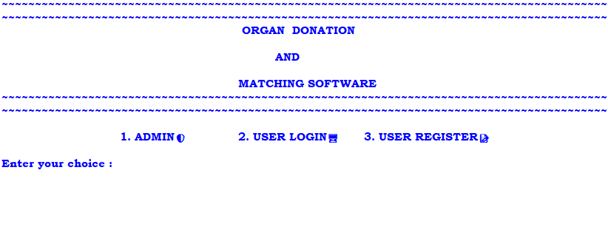

ADMIN
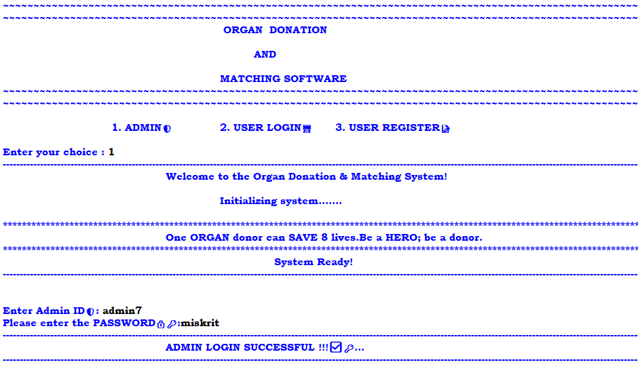

ADMIN MENU

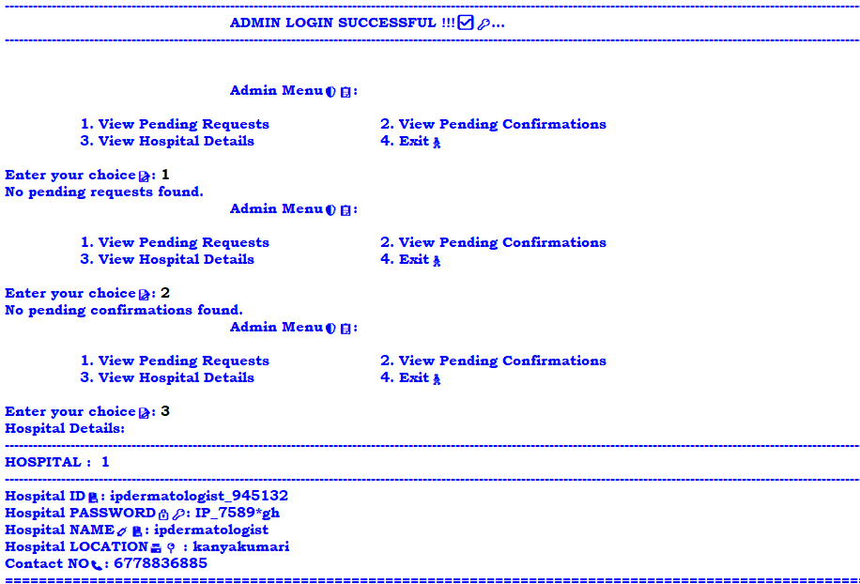

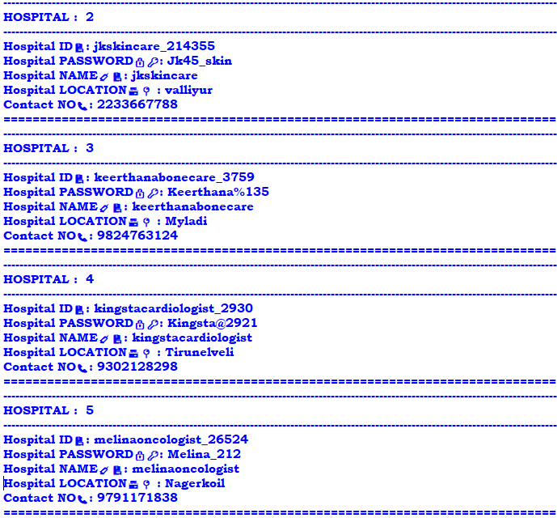

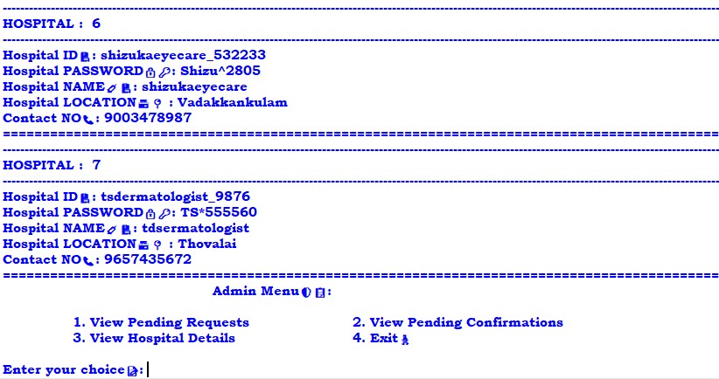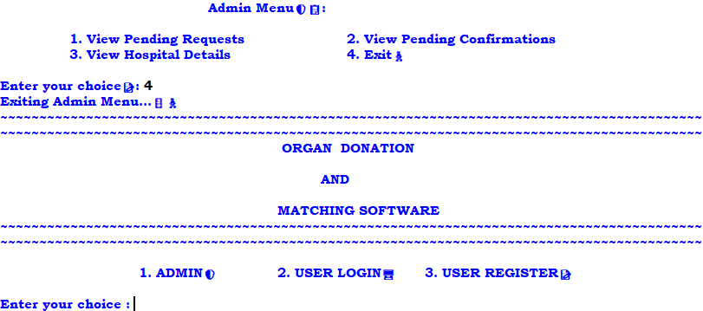
USER REGISTER

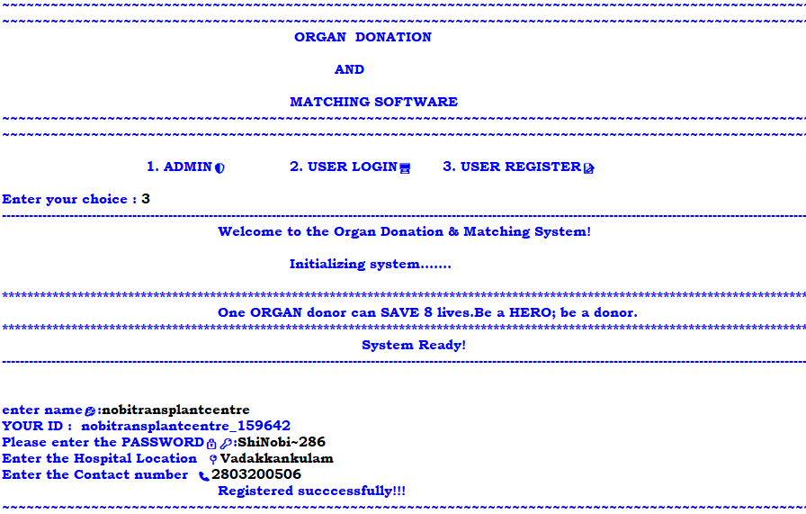

USER LOGIN

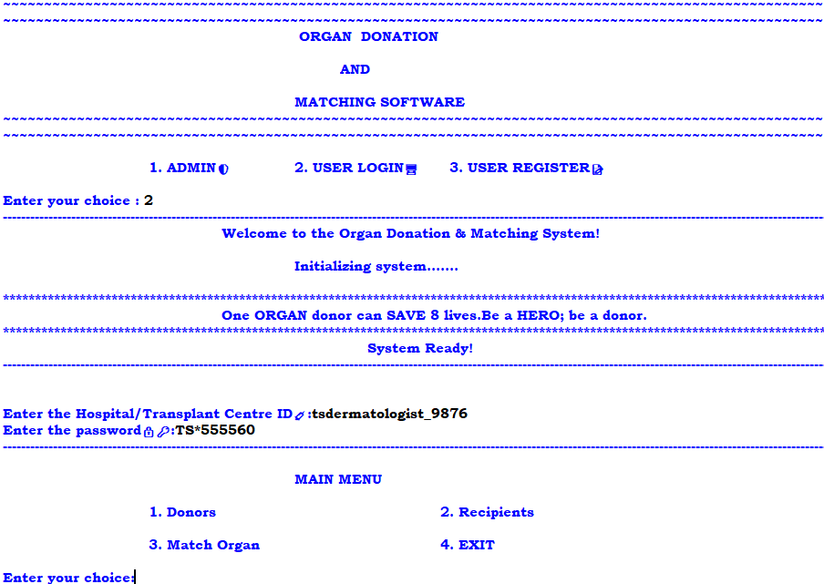

ADD DONOR

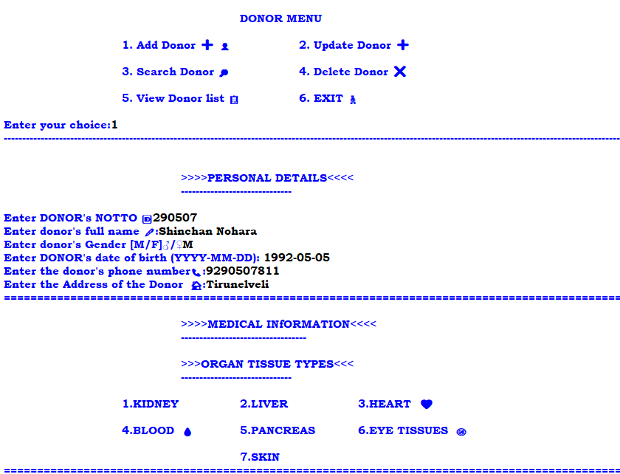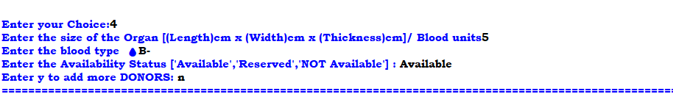

UPDATE DONOR

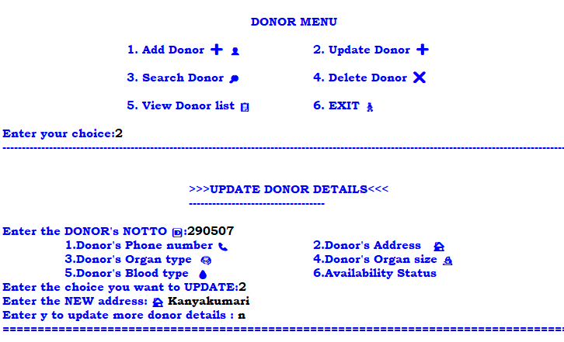
DELETE DONOR

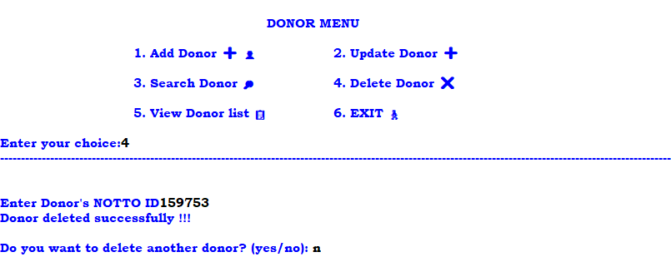

SEARCH DONOR

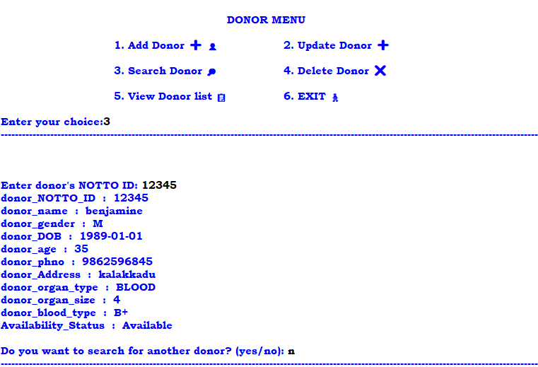

VIEW DONOR LIST


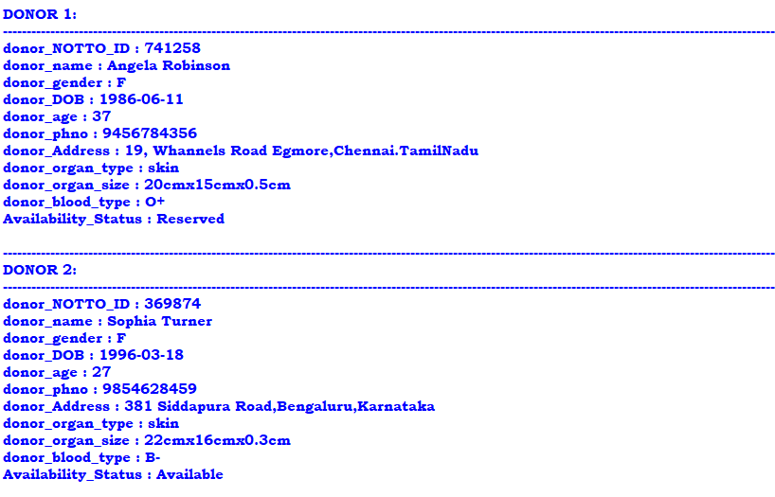
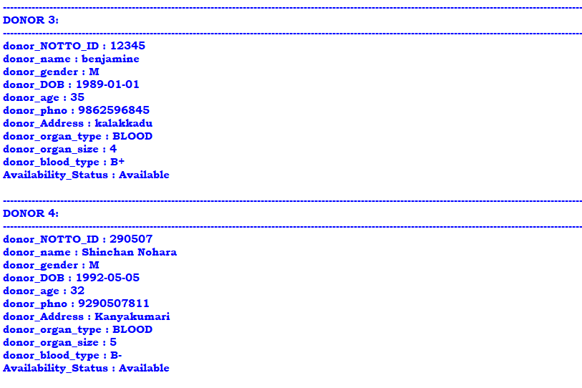
MATCHING SYSTEM

OUTPUT OF HOSPITAL (NEEDS ORGAN):

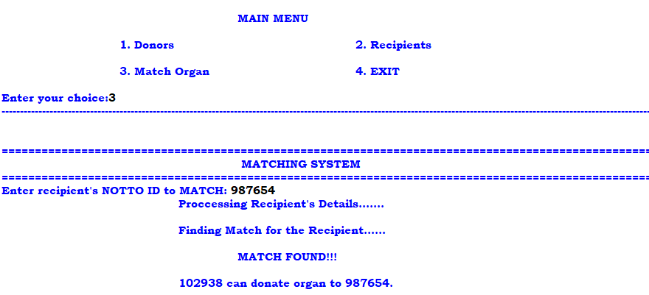
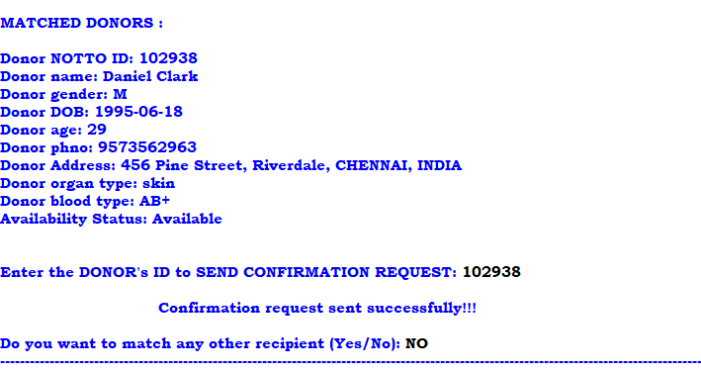

OUTPUT OF HOSPITAL (HAS ORGAN):

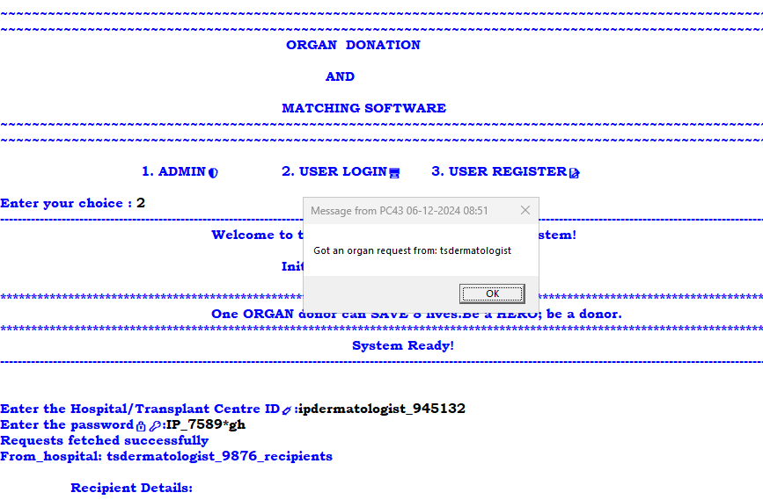
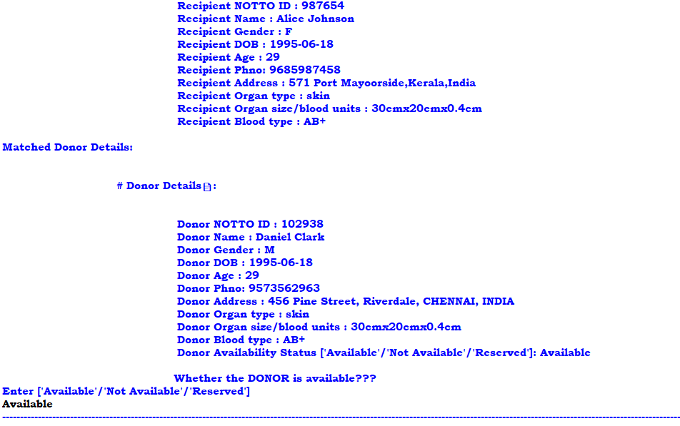

OUTPUT OF HOSPITAL(NEEDS ORGAN):

